The Skeleton Structure of HTML

<!doctype html> // advertise HTML that being doc format

<html>

<head>

=( link , instruction unseen content info)

<meta charset="UTF-8"> // UTF-8 compatible with multiple types of format

<title> Title Name </title>

// meta =information

// charset = character setting

// Title Name = The name which wants to be appear in the session bar

</head>

<body>

---------seen information ( content (text audio video image )

) ----------------------

---------------------------------

---------------------------------

</body>

===================================================================================================

Elements

------------

<p> -------text---------</P> // Paragraph text

|||||||||||||||||||||||||||||||||||||||||||||||||||||||||||||||

<h1> ---------------------</h1> // heading

*

*to

*

<h6> ----------------------</h6> // heading

H1 (biggest) to H6 (smallests)

||||||||||||||||||||||||||||||||||||||||||||||||||||||||||||||||

<b> ...<b/> // bold

or

<strong>...</strong> // <bold>

<i> ... </i> // italic

<em> ...< em> // emphasised = italic

<s> ......</s> // strike

<del> ......</del> delete = strike

< sup > ...</sup> // super scrypt

<sub> .....</sub> // sub scrypt

<br> ......</br> // break //next new line

<a href = "File Path"> Text here < /a>

||||||||||||||||||||||||||||||||||||||||||||||||||||||||||||||

Anchor

------

<p1 id="1" >

<p id="2" >

<p id="3" >

id = #

< a href = "#1" > P1 </a> <br>

< a href = "#2" > p2 </b> <br>

< a href = "#3" > p3 </b> <br>

# local internal

|||||||||||||||||||||||||||||||||||||||||||||||||||||||||||||||||

Day -2

List element # <li>

Order list <ol>

==========

1.sth

2.sth

3.sth

Unorder list <ul>

==============

* Sth
* Sth
* Sth

Reversed order list < ol reversed >

3.sth

2.sth

1.sth

Start order list < ol start “4” >

Start 4….5…..6….>>>

Start reversed order list< ol start reversed “5” >

Start 5….4….3….2…1

Defined order list element

<ol type “sth|A” >

<ul> ……………….</ul>

Table element ( <table>…………..</table>

|  |  |  |  |
| --- | --- | --- | --- |
| No | Item | Number | Element |
| 1 | Apple | 2 |  |
| 2 | Orange | 3 | 1000 |
| 3 | Banana | 10 | 1500 |

Table = Row * Column …………….Row =higher priority

Row = < tr > element

Column = <td> element

Sematic structure of table

Table (head) <thead>

Table (body) <tbody>

Table (foot) <tfoot>

<th> …….</th> = to make the table head letters BOLD !!!

|  |  |  |  |
| --- | --- | --- | --- |
| **No** | **Item** | **Number** | **Element** |

<table>

<thead>

<tr>

<th> Voucher </th>

</tr>

<tr>

<th> NO </th>

<th> Item </th>

<th> Number </th>

<th> Amount </th>

</tr>

</thead>

<tbody>

<tr>

<td> 1 </td>

<td>Apple</td>

<td> 2 </td>

<td> 500</td>

</tr>

<tr>

<td> 2</td>

<td> Orange </td>

<td> 3 </td>

<td> 1000 </td>

</tr>

<tr>

<td> 3 </td>

<td> Banana </td>

<td> 10 </td>

<td> 1500</td>

</tr>

</tbody>

<tfoot>

<tr>

<td> Copyright 2019 </td>

</tr>

</tfoot>

<table>

<form>

HTML entitled Symbole

# copy right C

# trademark TM

C* = & copy;

TM= &trad;

R*= &reg;

& lt = <

&gt = >

And many more……….

Form

Form < form> …………….</form>

<input type="submit" value="GO "> // GO = button

Input

Label=(First Name) >>>> input

<label> First Name </label> + <input type = “text”>

Label= (Last Name) >>>> input

<label> Last Name </label> + <input type = “text”>

Attach Label and Input

<label for = “Y” LABEL NAME </label>

<input type =”text” id= “Y” >

Clear form # < input type =”reset” value = “clear”>

Password

<label for="y"> Password </label>

<input type="password" id="y" required pattern="\S{6,}">

Explanation >>>/ S = non-white space character( no space allowed)

XXXXXXXXXXXXXXXXXXXXXXXXXXXXXXXXXXXXXXXXXXXXXXXXXXXX

Day-3

Email

< label for="Y"> Email </label>

<input type="email" id="Y" >

Search

<label for="z">Search </label>

<input type=”Search" id="z" >

URL

<label for="z">URL</label>

<input type="URL" id="z" >

Compulsory filling

<label for="N"> ID </label>

<input type="ID" id="N" required aria-required="true" >

Placeholder

<label for="P"> ID </label>

<input type=" ID " id="P" placeholder="type here">

Check Box

<label> Select Your Favourite Fruits </label>

<input type="checkbox" id="a"> <label for="a"> apple</label>

<input type="checkbox" id="o"> <label for="o"> orange</label>

<input type="checkbox" id="b"> <label for="b"> banana</label>

Drop Box

<SELECT>

<option> 1</option>

<option> 2</option>

<option> 3</option>

</SELECT>

Radio

<label> Select Your Gender </label>

<input type="radio" id="m" name="Gender"> <label for="m"> male</label>

<input type="radio" id="f" name="Gender"> <label for="f"> female</label>

NOTE # ( name = “Gender” ) means to form a GROUP to avoid selecting more than one

Auto-fill

<label for="N"> Name </label>

<input type="text" id="N" autocomplete="on">

# # # <input type="text" id="N" autocomplete="OFF">

Text Area ( full element)

< textarea> …………..</textarea>

Color Box

<input type=”color”>

Number

<label for="n"> I want <input type="number" id="n" min="1" max="9"> apple </label>

<label for="n"> I want <input type="number" min="1" max="9" id="n" > apple </label>

Video

<video src="Day-2.mp4"controls width="400" height="200"loop></video>

# loop # autoplay …..

<video src="Day-2.mp4"controls width="400" height="200"autoplay loop></video>

Preload Attribute

1.auto (offline)

2.none (stream)

Poster Attribute

<video src="Day-2.mp4"controls width="400" height="200"autoposter=”file.jpg”></video>

Mute video

<video src="Day-2.mp4"controls width="400" height="200"autoposter=”file.jpg audio =muted ”></video>

More than one video

<video (width height)controls>

<source src="Day-2.mp4">

<source src="Day-3.mp4">

<source src="Day-5.mp4">

</video>

Subtitle

<video src="Day-2.mp4"controls width="400" height="200"auto poster="car.jpg">

<track kind="subtitle" srclang="en" label="English"src="1.srt">

</video>

Audio

<audio src="222.mp3" controls width="400" height="200"autoplay>

</audmp3

Highlight

<p> ……………<mark> Myanmar</mark> ………….</p>

Small element

<p> <small > …..</small><p> Eg >> <p> I like <small> orange</small> </p>

Cite element ( reference)

<cite> …..</cite>

Result >> italic =cite

Div element

<div>……</div>

Clear

<input type="reset" value=" Clear ">

CSS (Cascading Style Sheets)

+++++++++++++++++++++++++++++

Selector

1. Element Selector
2. ID selector (#) high priority than class
3. Class Selector (.) low priority

Main Formula

Selector {

property : value ;

property : value;

……… : …….;

}

Turn <p> element into red

<style>

p {color :red;}

</style>

Style element (unseen content)

<head>

<style>

</style>

</head>

Element*

h1 {color :blue;}

body {color :blue; }

ID*

#aa {background-color :red;

Class *

.aa {background-color :red;}

Advanced Selector

Descandant Selector (nesting element control)

<p> This is test

<a href. ‘’ # ‘’’ > Google </a>

</p>

Child Selector (>)

Select direct element /ID/Class

< a href =” #” > Link One </a>

<P><a href = “#”> Link Two </a>

<strong> <a href=” #”> Link Tree </a> <strong>

</p>

<a href ="#" > Link One </a>

<p><a href = “#”> Link Two </a>

<strong> <a href="#"> Link Tree </a> <strong>

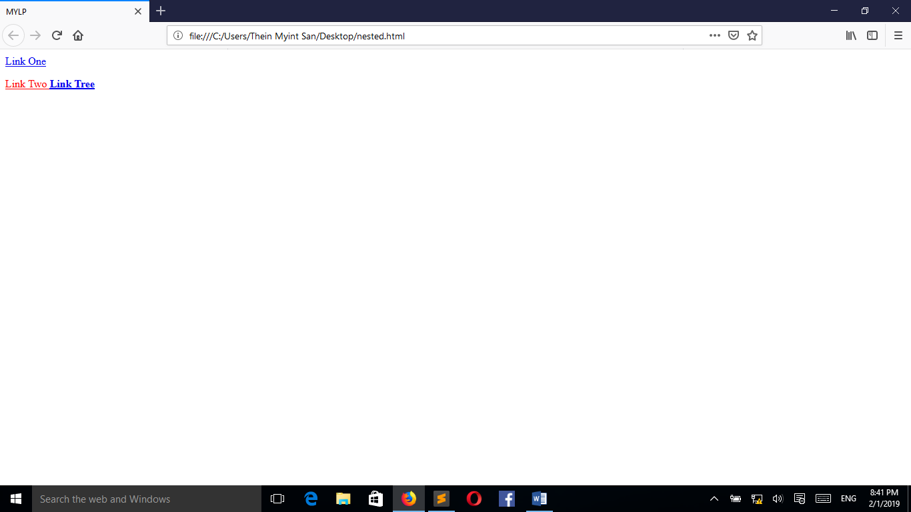

p > a ( color : red ;) ( result : above pic)

Attribute Selector (form and input )

Element [type =value]

{

property : values ;

}

Eg. Label { color : red ; }

Input [type = text]

{

color : red ;

}

Pseudo Class ( su dol) ( user interaction ) ( : )

a : hover {

color : green ;

}

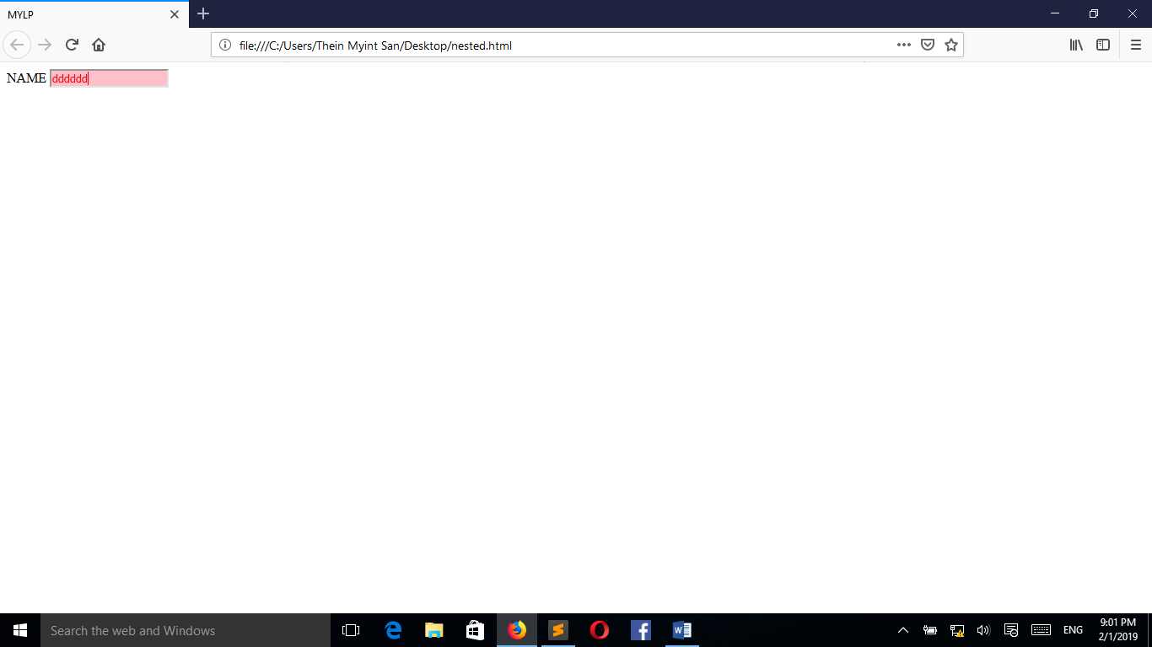

<style >

input[type=text]

{

color : red ;

background-color:pink;

}

</style>

Mouse Hovering interaction

============================

<style >

a{

color : yellow;

}

a:hover

{

color : red ;

}

</style >

Visited change color after visit link

+=====+

<style>

a{ color:red; }

a:visited{color:brown;}

</style>

</head>

<body>

<a href ="https://www.google.com" > www.google.com </a> <br> <br> <br> <br>

<label for="2"> NAME </label>

<input type ="text" id= "2" >

<br>

Active (common use in buttom)

<button > Click Here </button>

button: active{background-color: red}

button{background-color:yellow}

Focus (cursor)

<style>

input[type=text]

{

background-color:red ;

color: white ;

}

input[type=text]:focus

{

background-color:pink ;

color: black ;

}

</style>